

Traffic Study on Leeson Street – Mill Street West to Melody Lane

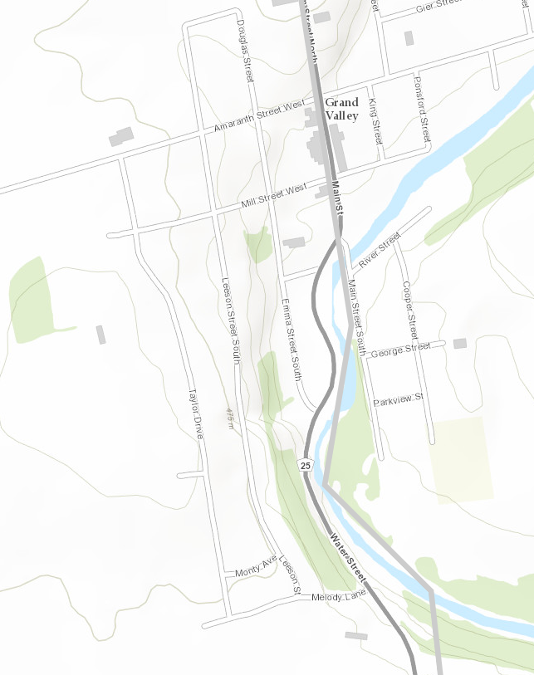
Residents have raised concerns about high traffic volume and speeding on Leeson Street and the surrounding road network. Staff have been monitoring the area and the Ontario Provincial Police have periodically been conducting speed limit enforcement.

In an effort to address residents’ concerns about the speed of traffic and safety on Leeson Street, Council has directed staff to implement a pilot traffic calming project, including speed cushions, in the Spring of 2024.

In order to properly define this pilot project staff will be conducting a series of traffic studies including a license plate survey and speed monitoring on Leeson Street.

Speed counting equipment and staff will be stationed along Leeson Street starting the week of September 25, 2023 and will be monitoring the area over the following two weeks.

By assessing the traffic conditions in this neighbourhood, the Town can identify the appropriate road safety opportunities for pedestrians, cyclists, and vehicular road users to serve all modes of transportation better.

If you have any questions please contact:

Matthew Bos, Director of Public Works
mbos@townofgrandvalley.ca

Donna Tremblay, Deputy Clerk/Communications Coordinator
dtremblay@townofgrandvalley.ca

Town of Grand Valley
5 Main St. N. | Grand Valley, Ontario | L9W 5S6

First published: September 25, 2023

